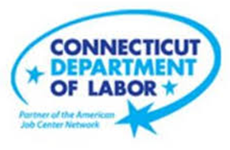

**NEW WEEKLY JOB POSTINGS FROM   
HELP WANTED ONLINE  
Office of Research**

**Week Ending March 11th, 2023: Weekly New Ads up 8% Over the Week**WETHERSFIELD, March 17th, 2023 – During the week ending March 11th, there were 6,287 new postings, up 487 new ads or 8% over the week. The industries with the largest over-the-week increases include Health Care, Educational Services, and Professional, Scientific, & Technical Services. Occupations with the largest over-the-week new ad increases include Registered Nurses (+61 new ads), Retail Salespersons (+41 new ads), and Wholesale & Manufacturing Sales Representatives (+37 new ads). This recent weekly rebound follows a two-week drop of over 1,100 new ads from 6,977 new ads during the week ending February 18th to 5,800 new ads during the week ending March 4th. The graph shown below illustrates total weekly new ad counts for Connecticut and the United States. Two weeks ago, the U.S. had total new ads fall by 19% and increase by 12% over the past week. These U.S. shifts are larger than the state, which was down 16% two weeks ago and up 8% over the past week.   
  
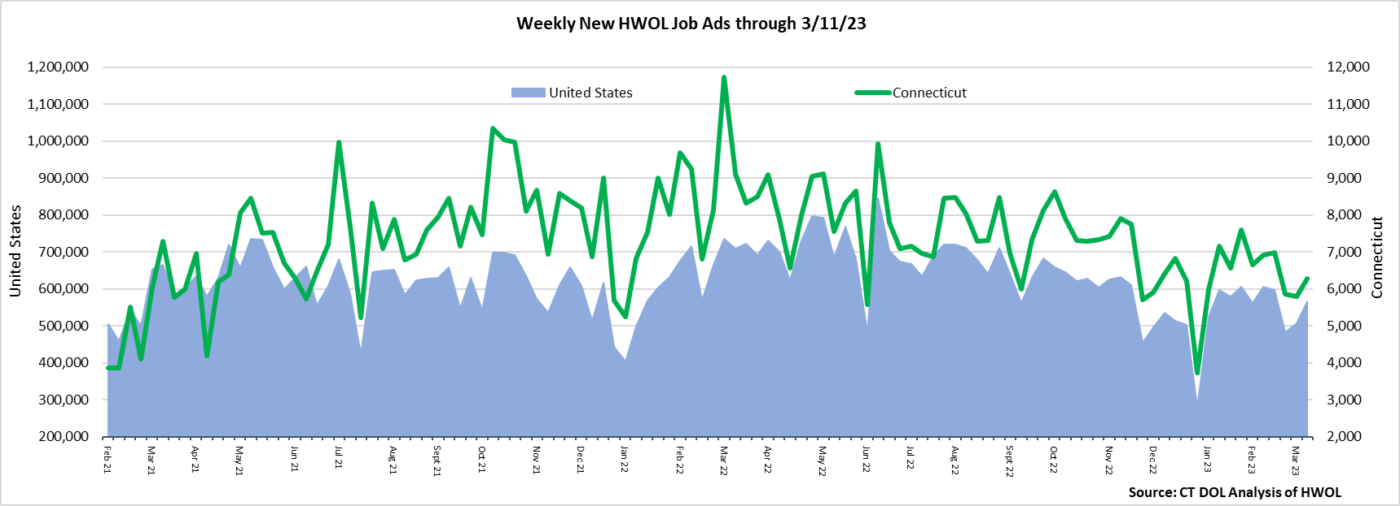  
**Industries** with the most new postings include Health Care & Social Assistance, Retail Trade, and Manufacturing.

**Occupations** with the most new postings include Registered Nurses, Retail Salespersons, and First-Line Supervisors of Retail Sales Workers.

**Employers** with the most new postings include Hartford Healthcare, Cigna Corporation, and Community Health Center, Inc.

**The three industries with the most new job postings were:**

* **Health Care & Social Assistance** (1,459 new postings, +11% over the week)
* **Retail Trade** (528 new postings, +5% over the week)
* **Manufacturing** (474 new postings, +5% over the week)

   
 During the week ending March 11th, 2023, fourteen of twenty-one industries had over-the-week increases. The largest increases occurred within Healthcare & Social Assistance (+139 new ads), Educational Services (+60 new ads), and Professional, Scientific, & Technical Services (+50 new ads). The largest employer increases within those three industries respectively were the Child Guidance Center of Southern Connecticut (+47 new ads), the University of Connecticut (+11 new ads), and Quest Global (+15 new ads). Among the seven decreasing industries, the largest was Accommodation & Food Services (-105 new ads). The remaining six industries with over-the-week decreases fell by fewer than 34 new ads.   
  
 For more information on total job ads by industry for Connecticut and its labor market areas, see the monthly report available here: <https://www1.ctdol.state.ct.us/lmi/hwol.asp>

**New Job Postings by Occupation** d

**The occupations with the most new postings were:**

* Registered Nurses (375 new postings, +19% over the week)
* Retail Salespersons (215 new postings, +24% over the week)
* Managers (166 new postings, +9% over the week)

**Employers with the Most New Job Postings** Employers with the most new job postings during the week ending March 11th were mostly within Health Care & Social Assistance, Retail Trade, and Finance & Insurance. Health Care & Social Assistance accounted for eight of the top 25 employers. The 25 employers shown above combined account for 846 of total job ads or 13 percent of all new ads. They were up a combined 222 new ads from a week ago. The largest over-the-week increases occurred at Child Guidance Center of Southern CT (+47 new ads) and Travelers (+44 new ads). The largest over-the-week declines among the top 25 employers were Yale-New Haven Health System (-35 new ads) and the State of Connecticut (-30 new ads).  
  
**What is HWOL?**The **Conference Board Help Wanted Online**® Data Series (HWOL) measures the number of new, first-time Online job postings and jobs reposted from the previous month for over 16,000 Internet job boards, corporate boards, and smaller job sites that serve niche markets and smaller geographic areas. To view more HWOL data, go to: <https://www1.ctdol.state.ct.us/lmi/hwol.asp>